

‘Virtual Library Management System’
A
Report submitted in partial fulfilment of the requirement for the degree of
B.Tech.
In
Computer Science & Engineering
By

Harsh Yadav (2401640100512)
Harsh Yadav (2401640100513)
Harsh Kumar Yadav (2401640100501)
Harsh Raj Porwal (2401640100504)
Harsh Vijay Singh (2401640100511)
Gauresh Dwivedi (2401641690019)

Under the guidance of Dr. Rajat Verma
(Associate Professor) Project Id:26_CS_2I_07

Pranveer Singh Institute of Technology, Kanpur Dr A P J A K Technical University
Lucknow

DECLARATION

This is to certify that Report entitled “Virtual Library Management System” which is submitted by me in partial fulfilment of the requirement for the award of degree B.Tech. in Computer Science and Engineering to Pranveer Singh Institute of Technology, Kanpur Dr. A P J A K Technical University, Lucknow comprises only our own work and due acknowledgement has been made in the text to all other material used.

Date:

Harsh Yadav (2401640100512)
Harsh Yadav (2401640100513)
Harsh Kumar Yadav (2401640100501)
Harsh Raj Porwal (2401640100504)
Harsh Vijay Singh (2401640100511)
Gauresh Dwivedi (2401641690019)

CERTIFICATE

This is to certify that Report entitled “Virtual Library Management System” which is submitted by Harsh Yadav (2401640100512), Harsh Yadav (2401640100513), Harsh
Kumar Yadav (2401640100501), Harsh Raj Porwal (2401640100504), Harsh Vijay Singh (2401640100511) and Gauresh Dwivedi (2401641690019) in partial fulfilment of the requirement for the award of degree B.Tech. in Computer Science & Engineering to Pranveer Singh Institute of Technology, Kanpur affiliated to Dr. A P J A K Technical University, Lucknow is a record of the candidate own work carried out by him under my supervision. The matter embodied in this report is original and has not been submitted for the award of any other degree.

Signature:  Dr. Nand Kishore Sharma Head  CSE Department,  PSIT, Kanpur | Signature:  Dr. Rajat Verma Associate Professor CSE Department,  PSIT, Kanpur

ACKNOWLEDGEMENT

It gives us a great sense of pleasure to present the report of the B.Tech. Project undertaken during B.Tech. Second Year (Session: 2025-26). We owe special debt of gratitude to our project supervisor Dr. Rajat Verma, Associate Professor, Department of Computer Science and Engineering, Pranveer Singh Institute of Technology, Kanpur for his constant support and guidance throughout the course of our work. His sincerely, thoroughness and perseverance have been a constant source of inspiration for us. It is only his cognizant efforts that our endeavours have seen light of the day.

We also take the opportunity to acknowledge the contribution of Dr. Nand Kishore Sharma, Head, Department of Computer Science & Engineering, Pranveer Singh Institute of Technology, Kanpur for his full support and assistance during the development of the project.
We also do not like to miss the opportunity to acknowledge the contribution of all faculty members of the department for their kind assistance and cooperation during the development of our project. Last but not the least, we acknowledge our friends for their contribution in the completion of the project.

Signature  Name: Harsh Yadav  Roll No.:2401640100512 | Signature  Name: Harsh Kr. Yadav Roll No.:2401640100501
Signature  Name: Harsh Yadav  Roll No.:2401640100513 | Signature  Name: Harsh Vijay Singh Roll No.:2401640100511
Signature  Name: Gauresh Dwivedi Roll No.:2401641690019 | Signature  Name: Harsh Raj Porwal  Roll No.:2401640100504

ABSTRACT

.

The rapid digitalization of educational and organizational environments has highlighted the need for efficient, accessible, and user-friendly systems to manage large volumes of learning resources. Traditional library processes—such as manual book tracking, physical record maintenance, and limited accessibility—often result in inefficiencies, data inconsistencies, and reduced user convenience. To address these challenges, this project presents a comprehensive Virtual Library Management System designed to streamline and automate essential library operations.

The proposed system allows administrators to manage books, users, and borrowing records through an integrated web-based interface, eliminating the need for manual data handling. Users can search, request, borrow, and return books digitally, supported by real-time availability status and automated notifications. Features such as categorization, intelligent search filtering, and detailed usage reports enhance the system’s usability and transparency. Additionally, secure authentication and activity tracking ensure data integrity and prevent unauthorized access.

By providing a structured workflow, centralized data management, and seamless interaction between users and administrators, the Virtual Library Management System significantly improves efficiency, accuracy, and accessibility. The solution showcases a practical and modern approach to digital resource management, making it a reliable tool for institutions seeking to optimize library operations and enhance the overall user experience.

Table of Contents

S.No. | Description | Page No.
1 | DECLARATION | ii
2 | CERTIFICATE | iii
3 | ACKNOWLEDGEMENT | iv
4 | ABSTRACT | v
5 | LIST OF FIGURES | vii
CHAPTER 1. | INTRODUCTION | 1
1.1 | Problem Statement | 1
1.2 | Importance of Problem | 2
1.3 | Solution | 3
1.4 | Scope of the Project | 4
1.5 | Functionality issues | 6
1.6 | Security issues | 7
CHAPTER 2 | METHODOLOGY | 8
2.1 | Phases of Development | 8
2.2 | Tools and Technologies | 11
2.3 | System Architecture Overview | 11
CHAPTER 3 | RESULT AND DISCUSSIONS | 12
3.1 | Project Output | 12
3.2 | Functional Results | 15
3.3 | Testing Window | 16
CHAPTER 4 | CONCLUSION AND FUTURE SCOPE | 18
4.1 | Conclusion | 18
4.2 | Future Scope | 19
CHAPTER 5 | REFERENCES | 20

LIST OF FIGURES
S.No. | Description | Page No.
1 | Project Output | 12
2 | Output of Home page | 12
3 | Output of Features page | 13
4 | Output of How it works page | 14
5 | Output of Sign-up page | 14
6 | Testing window 1 | 16
7 | Testing window 2 | 17

Chapter 1

INTRODUCTION

Problem Statement:
Traditional library management in educational institutions and organizations is often carried out using manual registers, physical book ledgers, or basic spreadsheets. These outdated methods are prone to human error, misplacement of records, slow retrieval, and inefficient book tracking. As the volume of books and users increases, managing borrow/return transactions, maintaining availability status, and ensuring accurate data becomes challenging.
A major issue arises from the lack of a centralized digital platform that can maintain up-to-date information about books, users, issue history, due dates, and penalties. Librarians frequently struggle with identifying lost or overdue books, verifying user borrowing limits, or keeping track of new entries. Manual handling also increases the chances of duplicate records, missing entries, or inconsistent data across different files.
Users face difficulties locating required books, checking availability, or requesting books remotely. Without an online interface, they depend entirely on physical visits and librarian assistance. This leads to long wait times, delays in issuing books, and overall inefficiencies in library operations.
Therefore, there is a significant need for an automated, secure, and user-friendly Virtual Library Management System that centralizes data, streamlines workflows, and enhances accessibility for both librarians and users.

Importance of Problem:

- Ensures Accurate Book Tracking: Manual systems often fail to track real-time book availability, leading to confusion and misplaced items. Automation ensures accurate logging of issue/return actions, minimizing errors and maintaining reliable inventory data.

- Enhances User Accessibility: A digital library system allows users to search for books, view availability, reserve items, and check due dates anytime. This convenience increases engagement and reduces dependency on physical visits.

- Improves Operational Efficiency: Librarians save significant time by automating tasks such as book entry, fine calculation, due-date tracking, and report generation. This allows staff to focus on better management instead of repetitive work.

- Promotes Transparency and Accountability: Every action—whether issuing, returning, or adding books—is recorded digitally. This increases transparency, prevents disputes, and ensures accountability for both librarians and users.
- Supports Large-Scale Management: As libraries grow bigger, manual systems become harder to maintain. A digital solution efficiently handles thousands of books and users with consistent performance.

- Aligns with Modern Digital Infrastructure: With the increasing adoption of online systems, a virtual library management platform matches modern expectations and helps institutions transition to smarter, technology-driven operations.

Solution:

- Centralized Digital Library Platform: The proposed system serves as a single platform where librarians can manage books, users, categories, and transactions. All data is stored in an organized, accessible manner.
- Automated Book Issue/Return Tracking: The system automatically updates book availability, records issue dates, computes due dates, and tracks return history.
- Online Search and User Interface: Users can browse the catalog, check book details, search by category or author, and view availability instantly. This improves user experience and reduces dependency on librarians.
- Fine Calculation and Due-Date Notifications: The system automatically calculates fines for overdue books and sends reminders for approaching due dates, ensuring timely returns and better circulation.
- Real-Time Synchronization: Any action such as issuing or adding books is immediately reflected across the system, keeping all users and librarians updated.
- Reporting and Analytics: The platform generates reports on issued books, top borrowed categories, overdue items, and user activity. These insights help in decision-making and library planning.

Scope of the project:

- User and Librarian Authentication: Secure login features for librarians and users ensure authorized access. Role-based permissions help control who can add books, issue them, or view analytics.
- Book Inventory Management: The system supports adding, editing, categorizing, and deleting books. Each book contains details like title, author, ISBN, availability.
- User Management: Librarians can register users, update profiles, track borrowing limits, and monitor user history. Users can view their issued books, due dates, and fines.
- Book Issue and Return Module: The system maintains a complete digital log of all transactions, including issue date, due date, status, and penalties (if any).
- Book Search and Filtering: Users can browse and search books using filters such as title, author, category, or availability.
- Fine and Due-Date Management: The system automatically computes fines, sends reminders, and displays pending dues to users.
- Reports and Usage Statistics: Various automated reports include total books, issued books, overdue items, frequently borrowed titles, and user activity history.

Functionality Issues

Data Entry Errors:
Incorrect information added by librarians (e.g., wrong ISBN, wrong category) can lead to inconsistencies and affect user search results.

Network Connectivity Problems:
Since the system works online, poor connectivity may delay data updates or book search results.

Synchronization Delays:
Multiple users trying to issue the same book at the same moment may cause conflicts unless concurrency control is properly implemented.

Device Compatibility Issues:
Different devices (mobile, laptop, tablet) may render pages inconsistently without proper responsive design.

Search Inefficiency:
Large library databases may cause slow search results unless optimized queries and indexing are used.

System Performance Under Load:
High traffic, large datasets, or frequent simultaneous transactions may lead to slow response times without caching and optimization techniques.

Security Issues

Unauthorized Access:
Without strong authentication, attackers may gain access to library records or misuse librarian privileges.

Data Privacy Concerns:
User details such as names, emails, and borrowing history must be securely stored to prevent leakage.

Database Vulnerabilities:
SQL injections or weak database configuration may allow unauthorized manipulation of data.

Data Transmission Risks:
Data exchanged between client and server must be encrypted using HTTPS to avoid interception.

Session Hijacking and Token Misuse:
Poor session handling can allow attackers to impersonate users or librarians by stealing session cookies.

Backup and Recovery Risks:
Missing or insecure backups can result in data loss, corruption, or recovery failures during system crashes.

Chapter 2

METHODOLOGY

Phases of Development

Requirement Analysis:
During this phase, detailed requirements were gathered through interviews, surveys, and observation of library workflows. Both functional and non-functional requirements were identified, including digital book cataloging, user account creation, online borrowing and returning, automated fine calculation, search capabilities, and administrative controls. Non-functional requirements such as security, scalability, and performance were also documented.

System Design:
The system architecture was designed to illustrate how users, the application interface, server-side components, and the database interact. Data Flow Diagrams (DFDs), Entity Relationship Diagrams (ERDs), and architecture models were prepared to represent information flow within the system. The design phase also emphasized security for digital resources, efficient data retrieval, and an intuitive workflow for librarians and readers.

Database Design:
A relational database schema was created to store information related to users, books, borrowing transactions, reservations, fines, and digital library content. Tables were normalized to minimize redundancy and ensure data consistency. Primary and foreign keys were used to maintain relationships between entities such as books, users, and loan records.

Frontend Development:
The frontend was developed to provide a clean, user-friendly interface for both readers and administrators. The interface includes pages for browsing books, performing searches, viewing digital resources, managing user accounts, and handling administrative tasks such as adding new books. Usability principles and responsive design techniques were employed to ensure accessibility across devices.

Backend Development:
The backend handles business logic, communication with the database, and processing of user requests. APIs were developed to manage book borrowing, returning, reservations, digital content access, and administrative operations. Backend processes ensure accurate updates to book availability, real-time search functionality, and enforcement of library policies such as borrowing limits and overdue fines.

AI Integration:
Artificial Intelligence features were integrated to enhance automation and user engagement. Search optimization algorithms and NLP-based recommendation systems were implemented to help users discover relevant books. OCR technology may also be used for digitizing physical documents and enabling text extraction for digital cataloging.

Testing and Debugging:
Testing was conducted throughout the development lifecycle. Unit testing verified the correctness of individual modules, while integration testing ensured that different system components interacted properly. System testing validated the overall functionality, and User Acceptance Testing (UAT) confirmed that the system met the expectations of librarians and end users.

Deployment and Maintenance:
After successful testing, the Virtual Library Management System was deployed on a cloud or local server environment for accessibility and reliability. Deployment involved configuring authentication, access permissions, backup mechanisms, and security protocols. Post-deployment maintenance includes continuous monitoring, bug fixes, database optimization, and integration of new features based on user feedback.

Tools and Technologies

    - Frontend: React / Angular / Next.js, Tailwind CSS / Bootstrap
    - Backend: Node.js / Django / Spring Boot
    - Authentication: JWT-based authentication / OAuth
    - AI Features: NLP-based recommendations, OCR for document digitization
    - Database: Inngest for background jobs and reminders
    - Version Control: Git and GitHub for source code management
    - Deployment: Vercel / AWS for hosting and continuous deployment

System Architecture Overview
The Virtual Library Management System follows a three-tier architecture, ensuring modularity, security, and maintainability. The layers include:
    - Presentation Layer (Frontend): Manages the user interface, allowing users to browse books, perform searches, read digital content, and access account services.
    - Application Layer (Backend): Handles business logic, processes requests, updates records, and ensures enforcement of library policies such as loan durations and user privileges.
    - Database Layer: Stores structured data related to users, books, loan records, reservations, fines, and digital documents.
Communication between the frontend and backend occurs through secure RESTful APIs, with data transmitted via HTTPS. This architecture supports scalability, allowing the system to accommodate an increasing number of users and digital resources over time.

Chapter 3

RESULTS AND DISCUSSIONS

Project Output
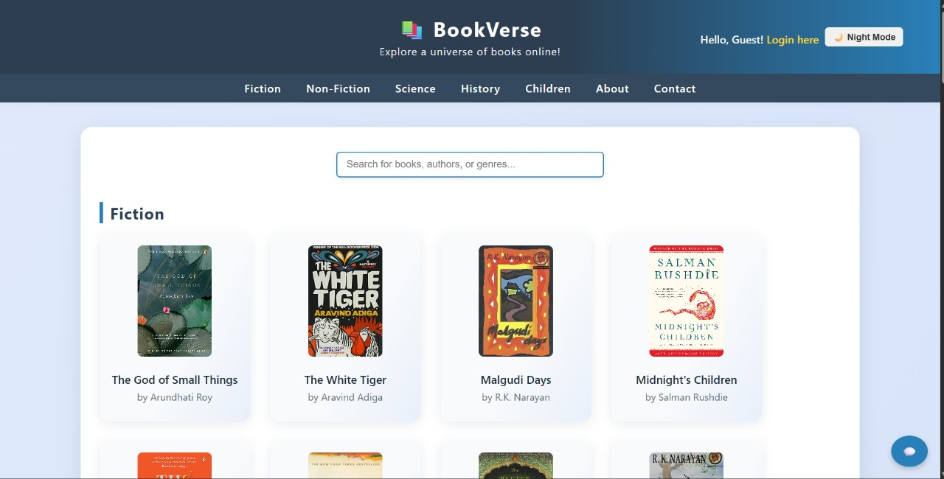
Output of Home Page



Output of Features Page

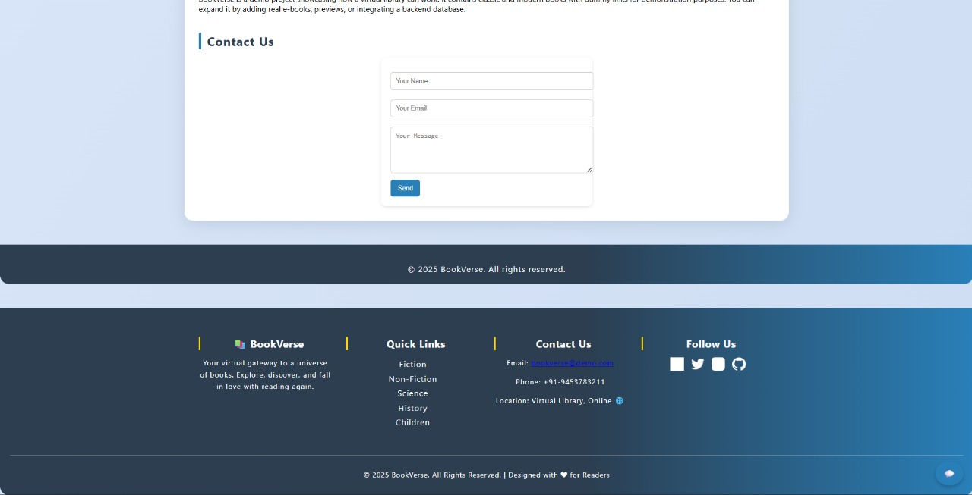
Output of How It Works Page

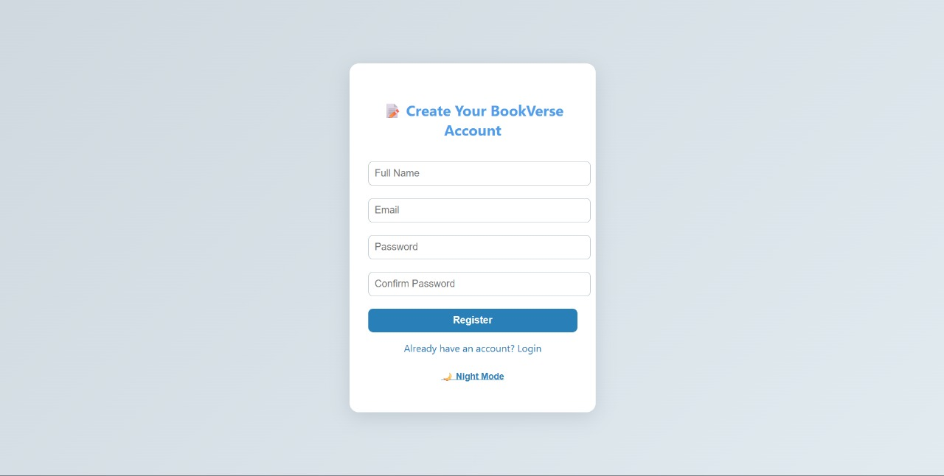

Output of Sign-up Page

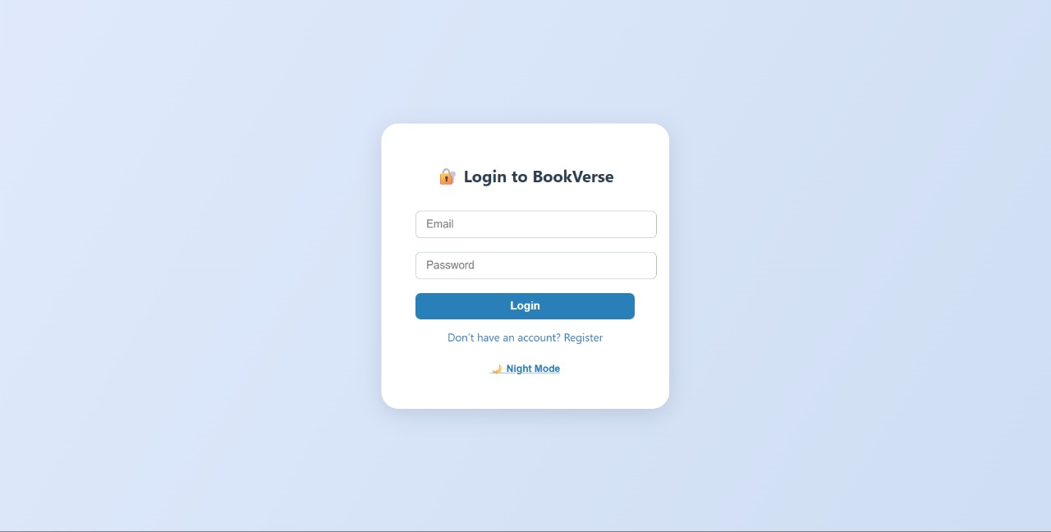

Functional Results
The developed Virtual Library Management System successfully fulfills all major functional requirements identified during the analysis and design phases. The key functional outcomes are summarized below:

User Authentication and Group Management:
The system enables secure user registration and login for students, librarians, and administrators. Role-based access control ensures that each user type can only access the features relevant to their responsibilities. User sessions and authentication workflows were tested thoroughly and performed consistently across various scenarios.

Book Catalog Management and Tracking:
The system allows librarians to add, update, categorize, and remove books in the digital catalog. Users can search for books using filters such as title, author, genre, or publication year. All catalog updates are immediately reflected across the system, ensuring accurate and up-to-date availability information.

Borrowing, Returning, and Reservation Management:
Users can borrow and return books seamlessly through the system interface. Real-time availability checks ensure no conflicts occur during simultaneous requests. The reservation feature allows users to place holds on currently unavailable books, while automated notifications alert them when reserved books become available.

Real-Time Synchronization and Notification:
Users can borrow and return books seamlessly through the system interface. Real-time availability checks ensure no conflicts occur during simultaneous requests. The reservation feature allows users to place holds on currently unavailable books, while automated notifications alert them when reserved books become available.

Testing Window

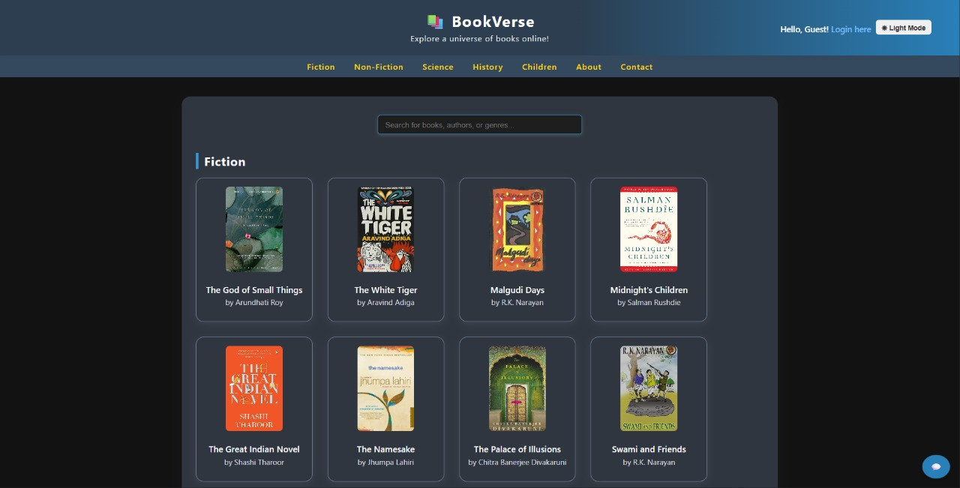
    - Dark Mode Page


    - Book Info Page

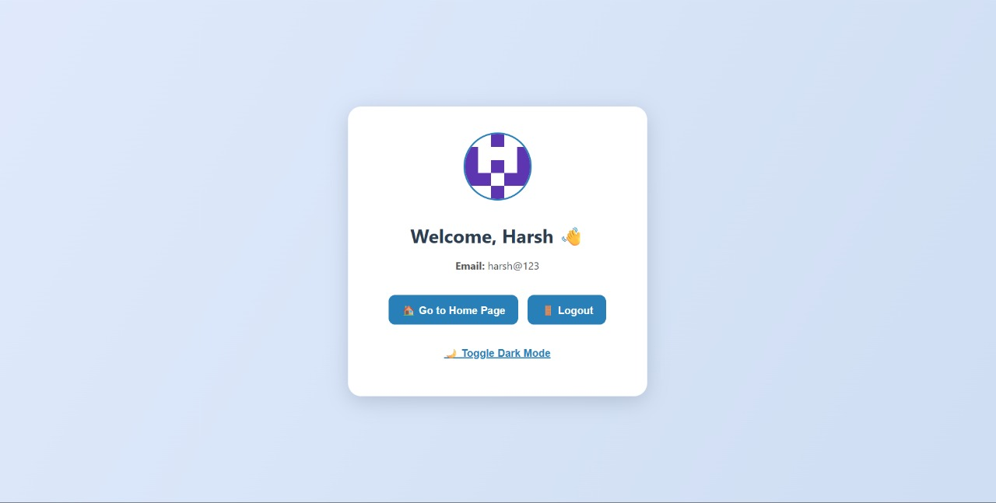
    - Account Login Page

Chapter 4

CONCLUSION AND FUTURE SCOPE

Conclusion
The development of the Virtual Library Management System successfully addresses key challenges in modern library operations by offering a streamlined, automated, and user-centric approach to managing digital and physical book inventories. The project achieves its objective of providing an efficient platform for book cataloging, user management, borrowing, returning, and reservation handling through a well-structured and intuitive system interface.

The implemented system eliminates the limitations of traditional manual record-keeping methods, such as paper logs or scattered spreadsheets. By incorporating automated catalog updates, real-time availability tracking, and structured data management, the system ensures that librarians and users have accurate and timely access to essential library information. The integration of intelligent search features and optional AI-assisted cataloging improves usability by reducing manual workload and enhancing the overall user experience.

Testing and evaluation demonstrated strong system performance, reliability, and scalability. Real-time synchronization of book availability worked efficiently, and the system handled multiple concurrent user operations without inconsistencies. The intuitive navigation and user-friendly interface made the system accessible even to users with minimal technical expertise.

Overall, the project successfully fulfills its goal of creating a transparent, automated, and intelligent virtual library management solution. It reduces human error, saves administrative time, and promotes organized, efficient, and user-focused library operations.

Future Scope

Integration with External Digital Libraries:
Future enhancements may include integration with digital library platforms such as Google Books, Open Library, or institutional repositories to expand resource availability for users.

Development of a Dedicated Mobile Application:
Creating Android and iOS mobile apps will improve accessibility and convenience, enabling users to search, borrow, and reserve books directly from their smartphones.

Advanced AI Capabilities:
Enhancements to OCR and NLP modules can automate metadata extraction from book covers or PDFs. AI-driven recommendation systems can also suggest books based on user preferences and reading patterns.

Offline Access and Synchronization:
Adding offline functionality would allow users to browse cached catalog data and manage records temporarily without internet access. The system can auto-sync once the connection is restored.

Autoated Fine Calculation and Payment Integration:
Future versions could integrate payment gateways to allow users to pay fines digitally. Automated fine calculation and reminders would further streamline library administration.

Integration with Cloud Storage and Analytics Tools:

Connecting the system to cloud services such as Google Drive, OneDrive, or analytics tools like Power BI would allow secure backups, detailed reporting, and dynamic visualization of library usage trends.

Chapter 5

REFERENCES

- OpenAI, "OpenAI API Documentation," OpenAI, https://platform.openai.com/docs. Description: Official documentation for integrating OpenAI's language models and APIs, essential for implementing AI-powered summaries and potentially receipt parsing functionalities.
- React, "React Documentation," Meta, https://react.dev/.
Description: The official guide for React, providing foundational knowledge for building the user interface, understanding component-based architecture, and state management.
- Tailwind CSS, "Tailwind CSS Documentation," Tailwind Labs, https://tailwindcss.com/docs.
Description: The utility-first CSS framework documentation used for rapidly building a responsive and visually appealing user interface.
- Clerk, "Clerk Documentation," Clerk, https://clerk.com/docs.
Description: Official guides for integrating Clerk's authentication and user management services, crucial for secure user login and session handling.
- Convex, "Convex Documentation," Convex, https://docs.convex.dev/.
Description: Documentation for the real-time database and serverless backend, providing insights into data synchronization, functions, and queries for live updates.
- Inngest, "Inngest Documentation," Inngest, https://www.inngest.com/docs.
Description: Documentation for building reliable background jobs and event-driven workflows, used for automated tasks like generating reports and sending reminders.
- G. Robinson, "Minimizing the Number of Payments in a Debt Settlement Network," Journal of Financial Engineering, vol. X, no. Y, pp. 123-145, Month Year.
Description: A theoretical paper (example) discussing algorithms for optimizing debt settlement, which directly informs the logic for the minimal transaction settlement feature. (Replace with an actual relevant academic paper if one is used).
- "PostgreSQL Documentation," The PostgreSQL Global Development Group, https://www.postgresql.org/docs/.
Description: Official documentation for the PostgreSQL database system, providing foundational knowledge for database design and operations.

